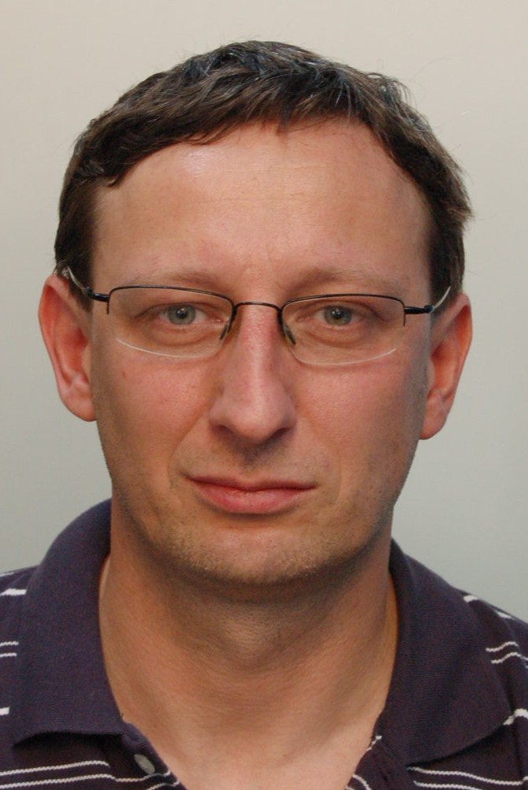
CURRICULUM VITAE

Name: Mgr. Petr Adamec, PMP
Nationality: Czech
Telephone: +420 725 583 176 – mobile
e-mail: adapet@seznam.cz
__________________________________________________________________________________
Employment:
2014-today SAS Institute CR, s.r.o.

Prague
July 2014 – today
Services Delivery Program Manager
Coordination of the all aspects of a product or service offering project for a client, from inception to installation. Projects are focused on the delivery of the new or enhanced products to improvement of customer satisfaction through the use of technology.
- Campaign management, On-line fraude management
Main responsibilities:
- Drive implementation life cycle
- Identify new software or services opportunities within the account
- Identify the interdependencies between the different projects
- Measure and monitor internal, external and stakeholder client satisfaction
- Assess and monitor risks, recommend and manage mitigating actions
- Facilitate and lead change through formal Change Management procedures
- Contribute leading practices and lessons learned
Customers from area banking and other financial area:
2009- 2014 Hewlett-Packard s.r.o.

Prague
October 2009 – January 2014
Customer project/program manager
Deputy of consultant manager for Czech Republic, Slovak Republic and SEE region. Management of CZ and SK country utilization
Bid management, management of SW products delivery and portfolio management:
- HP SOA Systinet, HP Server automation, HP Business Service Automation, HP Network node manager, HP Project and Portfolio Manager, HP Service Manager
Customers from areas:
- Banking and Insurance
- Government and State companies
- Mobile operators
- Logistic company
- Automotive
- Energy
Achievements:
- Projects level (100-700k USD, 3-10 project members)
- Customer surveys (100% satisfied, 90% very satisfied)
- 90% projects finished in time and budget, 10% finished before approved final date
2008- 2009 ITEG, a.s.

Prague
April2008 – June 2009
Senior project manager
Preparation of project management and portfolio management methodology Coordination of project portfolio (about 12 projects, total budget about 4 mld. CZK),
Implementation of project management and PMO including methodology
Couching of project managers and leadership of project support group
Project types:
- CA Clarity product implementation,
- Strategy advisory in project/program/portfolio m anagement
- ICT strategy preparation,
Customers:
- Governance
- Mobile operators

2001- 2007 Telefónica O2 Czech Republic, a.s. (previously Český Telecom, a.s.)

Prague

October 2005 – September2007

Manager of the Special Projects and Products Department

new business opportunities identification, description and realizations, coordination of the portfolio of the projects and new business opportunities

February 2004 – September 2005

Senior Project Manager – Pilot DVB-T (Digital Video Broadcast-Terrestrial) project - 20 team members, budget: tens mio CZK – pilot, hundreds mio CZK prepared commercial project , main results: 1. MHP application and HD terrestrial broadcasting in CR,1. DVB-T broadcasting in Brno,

September 2002 –January2004

Manager of the Central Project Office – coordination of corporate projects, programs and portfolios and PMOs of units, project management rules and methods, reports for TOP management, project prioritization, career plans for project management and project managers area,

September 2001 – September 2002

Manager of Company organization development – coordination of the corporate projects portfolio and preparation of the rules in the areas: central project office, holding management, SLA, Business planning

June 2001 – August 2001

Consultant for company organization development department project management rules, coordination of the corporate projects portfolio

1995 – 2001 Československá obchodní banka, a.s.
Prague

August 2000 – January 2001
Merger office member– co-ordination and planning of projects during integration IPB and CSOB

November 1999 – July 2000

Internal Consultant, chief of pilot branch team of branch enhancement program
January 1998 – November 1999
Responsible for project office management (building a project office – goals, human resources, new methodology, rules for portfolio and program management)
May 1996 – December1997
Member of the project office (methodology and consultant support of project leaders, coaching of project leaders, participation in managing projects and strategy of developing projects in CSOB as the tool for change management)
October 1995 – May 1996
Trainee

1994 – 1995 VÚMS Software
Prague
Member of the team with business and marketing tasks

Education:
1988 – 1994 Faculty of Mathematics and Physics of Charles University
Prague
Numerical methods algorithmic – optimalization
Finished by State examination

1984 – 1988 Secondary Grammar School
Komenského 5, Opava
Specialization: mathematics, physics, programming
Finished by school living exam

Courses:
2013 PMI certification
2013 preparation course for PMP certification - PM consulting
2013 IPMA recertification “C”
2010 ITIL foundation v3 certification
2009 Strategic project management, Expertis
2006 IPMA certification “C”
Inventa - certification courses Inter Project (CME, AMA, SSŘIP)
- Project management and project controlling
- Project management – negotiation and team work
  - Banking academy CSOB I,II

Languages:
English: active – CEFR level B2
Russian: passive – school-leaving exam
Polish: passive
Slovak: active – good

Other skills:
Driving licence B
internal coach (10 contracts-30 hours with internal coachee)

Prague, December 16th , 2014 ________________
Mgr. Petr Adamec, PMP

